Food Bank of the Albemarle
2017 Dine Out to Help Out Restaurant Participation Form Restaurants from across northeast North Carolina are invited to show their support for the more than 58,040 people facing food insecurity through Food Bank of the Albemarle’s Annual “Dine Out to Help Out” event. We can certainly use your support

Restaurants from across northeast North Carolina are invited to show their support for the more than 60,000 people facing food insecurity through Food Bank of the
in the fight against hunger, and encourage your participation on this special day.

HOW DOES IT WORK?

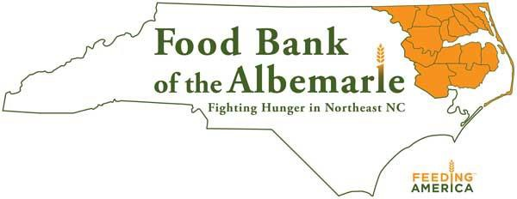
Each participating restaurant agrees to donate 10% of all proceeds earned on the designated Dine Out to Help Out date, Tuesday, September 12, 2017, to Food Bank of the Albemarle. In return, the Food Bank of the Albemarle will promote the event through social media, posters, handouts, and through other marketing venues such as newspapers and radio stations.

Restaurants will be supplied with signage, table top tents and other promotional materials to help make the event a success for the business and ultimately, for those families facing hunger in northeast North Carolina.

INTERESTED IN PARTICIPATING?
If you are interested in taking part in the 2017 Dine Out to Help Out efforts, please complete the section below: Restaurant Name:
Please print the restaurant name exactly as you would like it to appear in printed advertising.

Name of Authorized Personnel: Title:

Mailing Address: Physical Address:

City: State: Zip Code:

Telephone: Fax:

Email Address: Website:

Please indicate the number of each needed:
Table Top Tents ________ Large Poster (11x17) ________ Flyer (8.5 x 11) ________

By participating in Food Bank of the Albemarle’s 2017 Dine Out to Help Out fundraising campaign, I agree to donate
10% of our total receipts from the restaurant sales on Tuesday, September 12, 2017, for which we will be eligible for a tax deduction.

Signature: Date:

Please scan and e-mail this document by Monday, July 31, 2017 to:
caranderson@feedingamerica.org or fax it to 252-335-4797
Thank you for your commitment to help fight hunger!

For additional information, contact Carolyn Anderson, Director of Development
252-335-4035, ext. 111

FOOD BANK OF THE ALBEMARLE | PO BOX 1704 | 109 TIDEWATER WAY, ELIZABETH CITY, NC 27906-1704 | 252-335-4035

